**VISVESVARAYA TECHNOLOGICAL UNIVERSITY**

**“JnanaSangama”, Belgaum -590014, Karnataka.**



**LAB REPORT**

**on**

**Object Oriented Java Programming (23CS3PCOOJ)**

***Submitted by***

**Ayush Aditya(1BM23CS057)**

***in partial fulfillment for the award of the degree of***

**BACHELOR OF ENGINEERING**

***in***

**COMPUTER SCIENCE AND ENGINEERING**



**B.M.S. COLLEGE OF ENGINEERING**

**(Autonomous Institution under VTU)**

**BENGALURU-560019**

**Sep-2024 to Jan-2025**

**B.M.S. College of Engineering,**

**Bull Temple Road, Bangalore 560019**

(Affiliated To Visvesvaraya Technological University, Belgaum)

**Department of Computer Science and Engineering**



**CERTIFICATE**

This is to certify that the Lab work entitled “Object Oriented Java Programming (23CS3PCOOJ)” carried out by **Ayush Aditya(1BM23CS057),** who is bonafide student of **B.M.S. College of Engineering.** It is in partial fulfillment for the award of **Bachelor of Engineering in Computer Science and Engineering** of the Visvesvaraya Technological University, Belgaum. The Lab report has been approved as it satisfies the academic requirements in respect of an Object Oriented Java Programming (23CS3PCOOJ) work prescribed for the said degree.

|  |  |
| --- | --- |
| Lab faculty Incharge Name:Dr. Prasad G R  Department of CSE, BMSCE | Dr. Jyothi S Nayak  Professor & HOD  Department of CSE, BMSCE |

**Index**

|  |  |  |  |
| --- | --- | --- | --- |
| **Sl.**  **No.** | **Date** | **Experiment Title** | **Page No.** |
| 1 | 25-9-24 | Implement Quadratic Equation | 1-5 |
| 2 | 2-10-24 | Develop a Java program to create a class student with members usn,name and array marks.Include  methods to accept and display details and a method to calculate SGPA of student. | 6-12 |
| 3 | 9-10-24 | Create a class Book which contains four members: name, author,  price, num_pages. Include a constructor to set the values for the  members. Include methods to set and get the details of the objects.  Include a toString( ) method that could display the complete details of  the book. Develop a Java program to create n book objects. | 13-17 |
| 4 | 23–10-24 | .Develop a Java program to create an abstract class name shape that contains two integers and an empty method named printArea().Provide three classes named Rectangle,Triangle and Circle such that each one of the classes extends the class shape.Each one of the classes contain only the method printArea() that prints the area of the given Shape. | 18-22 |
| 5 | 30-10-24 | Create a class Account that stores customer name, account number and type of account. From this  derive the classes Cur-acct and Sav-acct to make them more specific to their requirements. Include  the necessary methods in order to achieve the following tasks: | 23-36 |
| 6 | 13-11-24 | Create a package CIE which has two classes- Student and Internals. The class Student has members like usn, name, sem. The class Internals derived from Student has an array that stores the internal marks scored in five courses of the  current semester of the student. Create another package SEE which has the class External which is a derived class of Student. This class has an array that stores the  SEE marks scored in five courses of the current semester of the student. Import the two packages in a file that declares the final marks of n students in all five courses. | 37-44 |
| 7 | 20-11-24 | Write a program that demonstrate handling of exception in inheritance String.Create a base class called Father and a derived class called son which extends the base class in Father’s class implement a constructor that takes the age and throws exception Wrong age when input age is less than 0.In son’s class implements constructor uses both father’s and son’s age and throws an exception when son’s age >= father’s age. | 45-51 |
| 8 | 27-11-24 | Write a program which creates two threads, one thread displaying “BMS College of Engineering” once every ten seconds and another displaying “CSE” once every two seconds. | 52-53 |
| 9 | 27-11-24 | Write a program that creates a user interface to perform integer divisions. The user enters two numbers in the text fields, Num1 and Num2. The division of Num1 and Num2 is displayed in the Result field when the Divide button is clicked. If Num1 or Num2 were not an integer, the program would throw a NumberFormatException. If Num2 were Zero, the program would throw an Arithmetic Exception Display the exception in a message dialog box. | 54-55 |
| 10 | 27-11-24 | Write a Java program to create two threads, one displays “Computer Science” and another display “Information Science” five times. | 55-56 |

Github Link:

https://github.com/Ayush-bmsce/Java_Lab

**Program 1**

Implement Quadratic Equation

Code:

import java.util.Scanner;

import java.util.lang.Math;

public class quadEq{

public static void main(String[] args){

System.out.println(("Enter coefficients a,b and c");

Scanner scanner = new Scanner(System.in);

int a = scanner.nextInt();

int b = scanner.nextInt();

int c = scanner.nextInt();

if(a == 0)

{

System.out.println("Not a quadratic Equation");

}

else{

int d = b*b-4*a*c;

if(d > 0){

float r1 = (-b+Math.sqrt(d))/(2*a);

float r2 = (-b-Math.sqrt(d))/(2*a);

System.out.println("r1 = " + r1);

System.out.println("r2 = " + r2);

}

else if(d == 0){

float r = -b/(2*a);

System.out.println("r = " + r);

}

else{

System.out.println("Roots are imaginary");

}

}

}

}

Output-

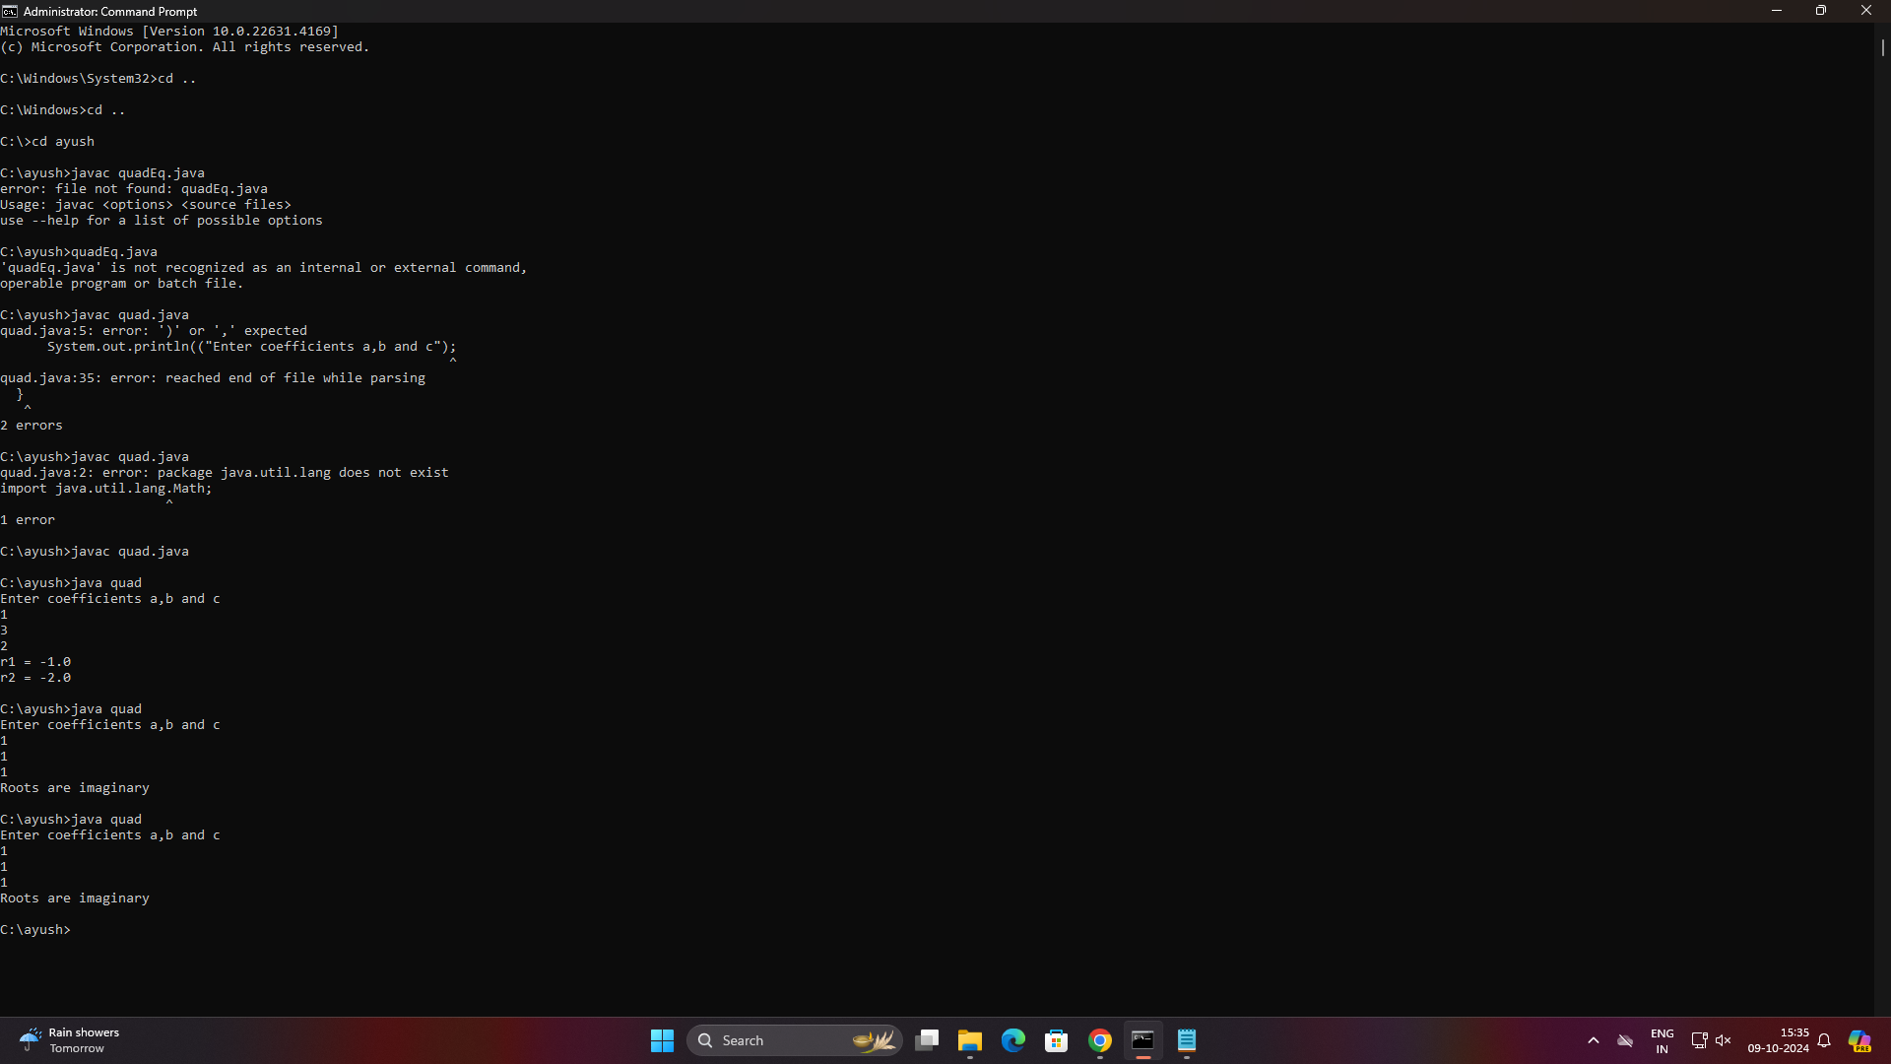

Observation Notebook-

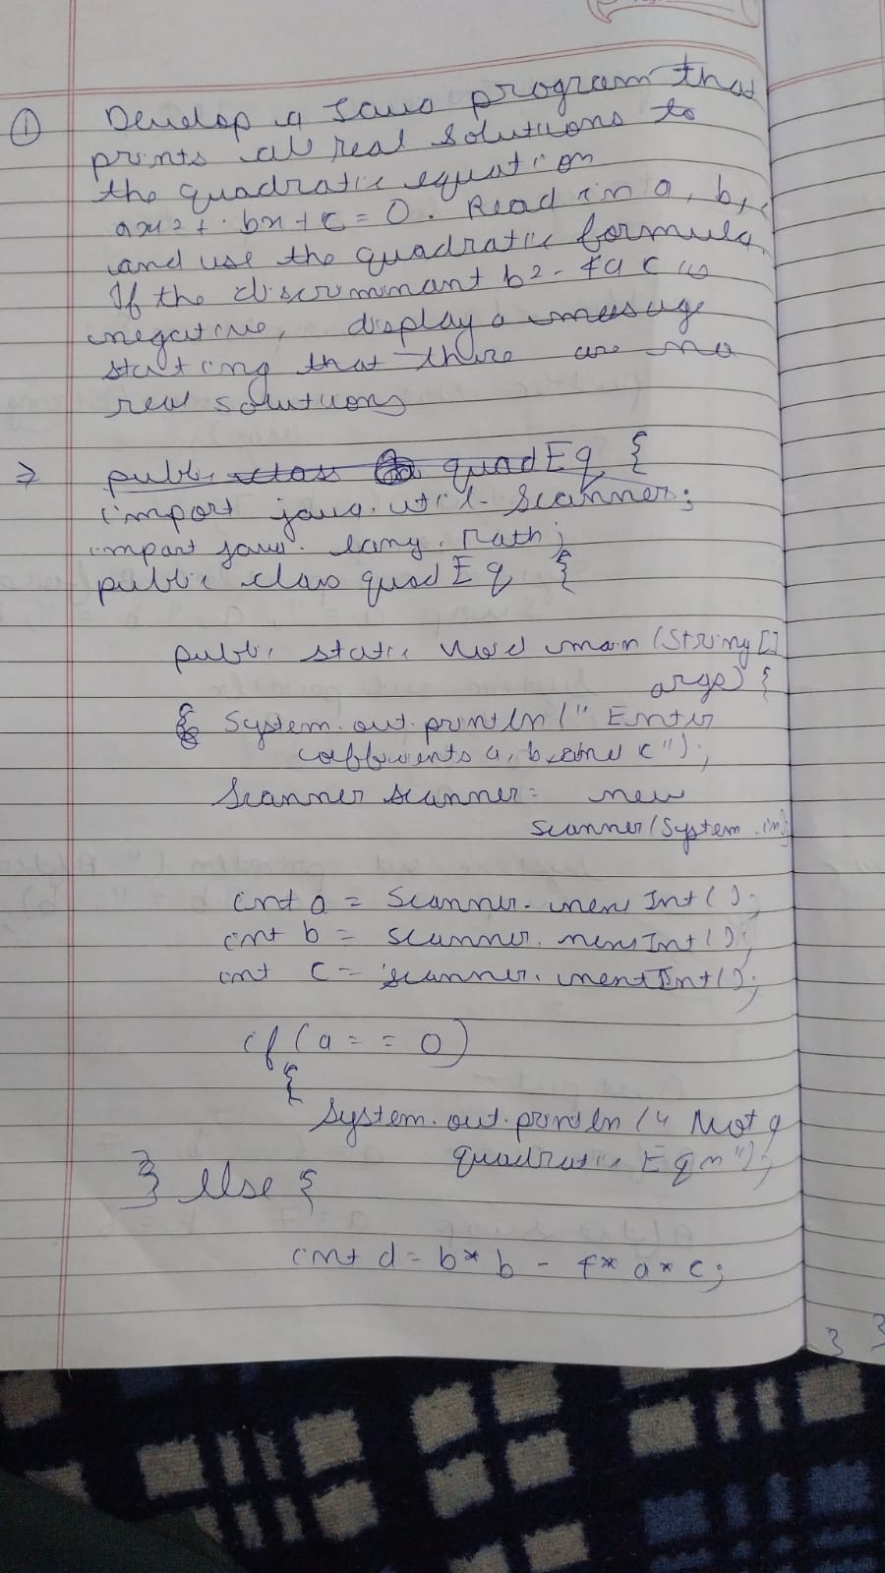

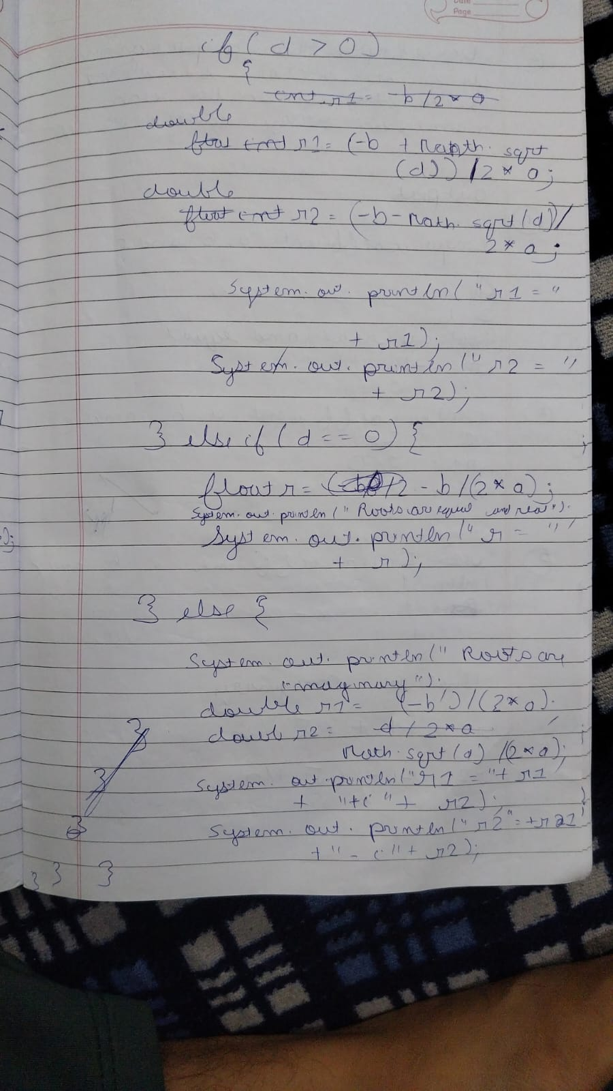

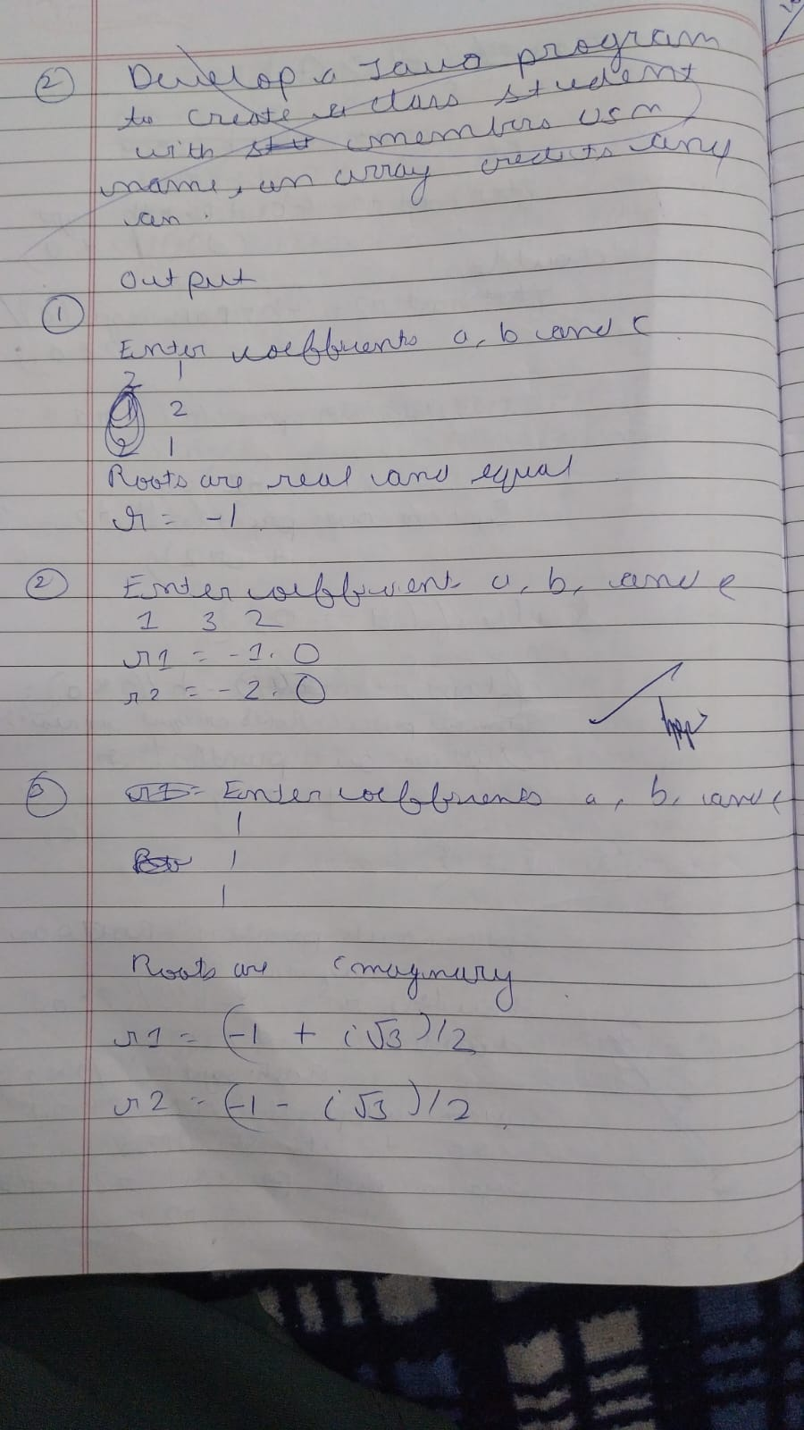

2.Develop a Java program to create a class student with members usn,name and array marks.Include methods to accept and display details and a method to calculate SGPA of student.

Code-

import java.util.Scanner;

class Subject {

int subjectMarks, credits, grade;

Subject subject[8];

}

class Student {

String name, usn;

double SGPA;

Scanner s = new Scanner(System.in);

Student() {

subject = new Subject[9];

for (int i = 0; i < 8; i++) {

subject[i] = new Subject();

s = new Scanner(System.in);

}

}

void getStudentDetails() {

System.out.println("ENTER YOUR NAME:");

name = s.nextLine();

System.out.println("ENTER YOUR USN:");

usn = s.nextLine();

}

void getMarks() {

for (int i = 0; i < 8; i++) {

System.out.println("enter marks of subject" + (i + 1) + ":");

subject[i].subjectMarks = s.nextInt();

System.out.println("enter credits of subject" + (i + 1) + ":");

subject[i].credits = s.nextInt();

if (subject[i].subjectMarks >= 90) {

subject[i].grade = 10;

} else if (subject[i].subjectMarks >= 80) {

subject[i].grade = 9;

} else if (subject[i].subjectMarks >= 70) {

subject[i].grade = 8;

} else if (subject[i].subjectMarks >= 60) {

subject[i].grade = 7;

} else if (subject[i].subjectMarks >= 50) {

subject[i].grade = 6;

} else if (subject[i].subjectMarks >= 40) {

subject[i].grade = 5;

} else {

subject[i].grade = 0;

}

}

}

void computeSGPA() {

int totalCredits = 0, total = 0;

for (int i = 0; i < 8; i++) {

totalCredits = totalCredits + subject[i].credits;

}

for (int i = 0; i < 8; i++) {

total = total + (subject[i].credits*subject[i].grade);

}

SGPA = total / totalCredits;

}

public static void main(String args[]) {

Student s1 = new Student();

s1.getStudentDetails();

s1.getMarks();

s1.computeSGPA();

}

}

Output-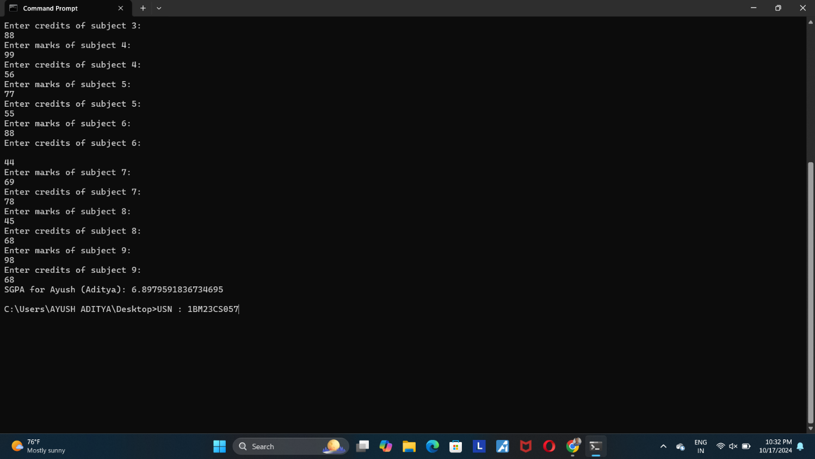

Observation notebook-

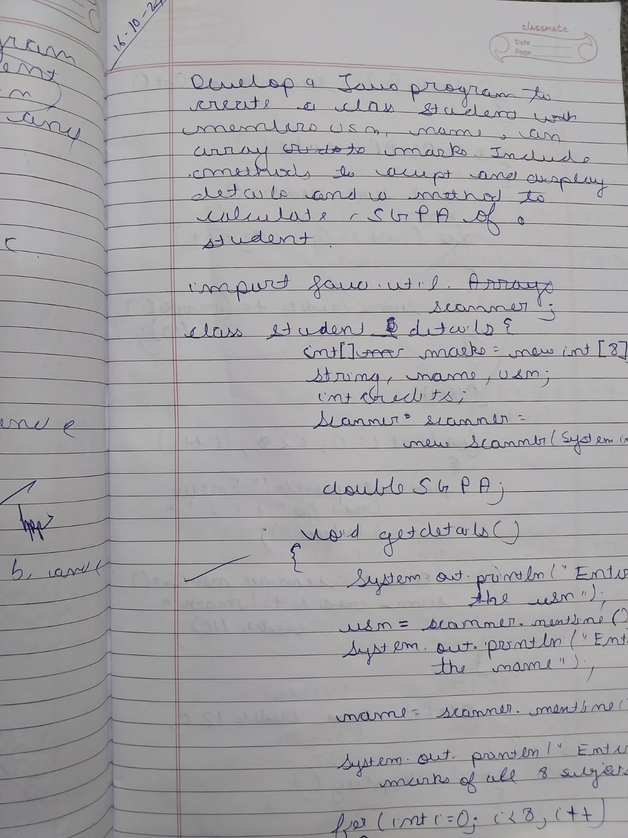

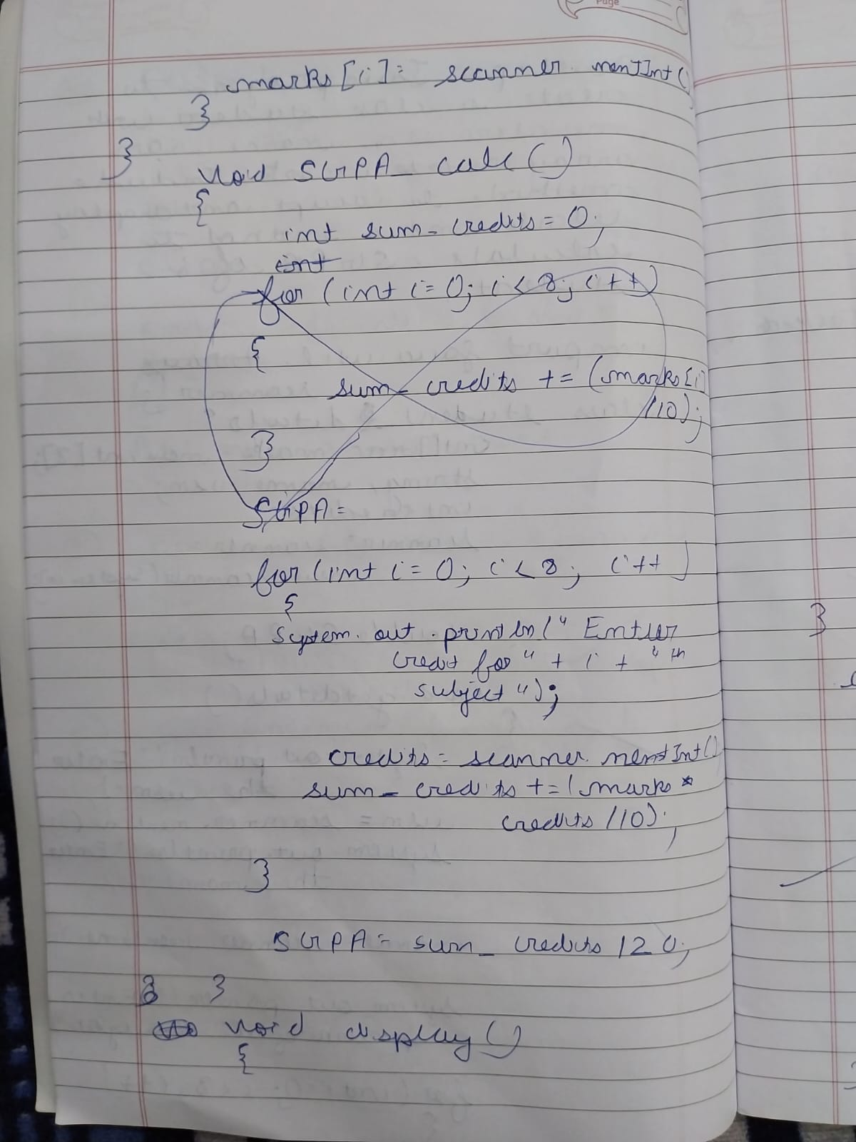

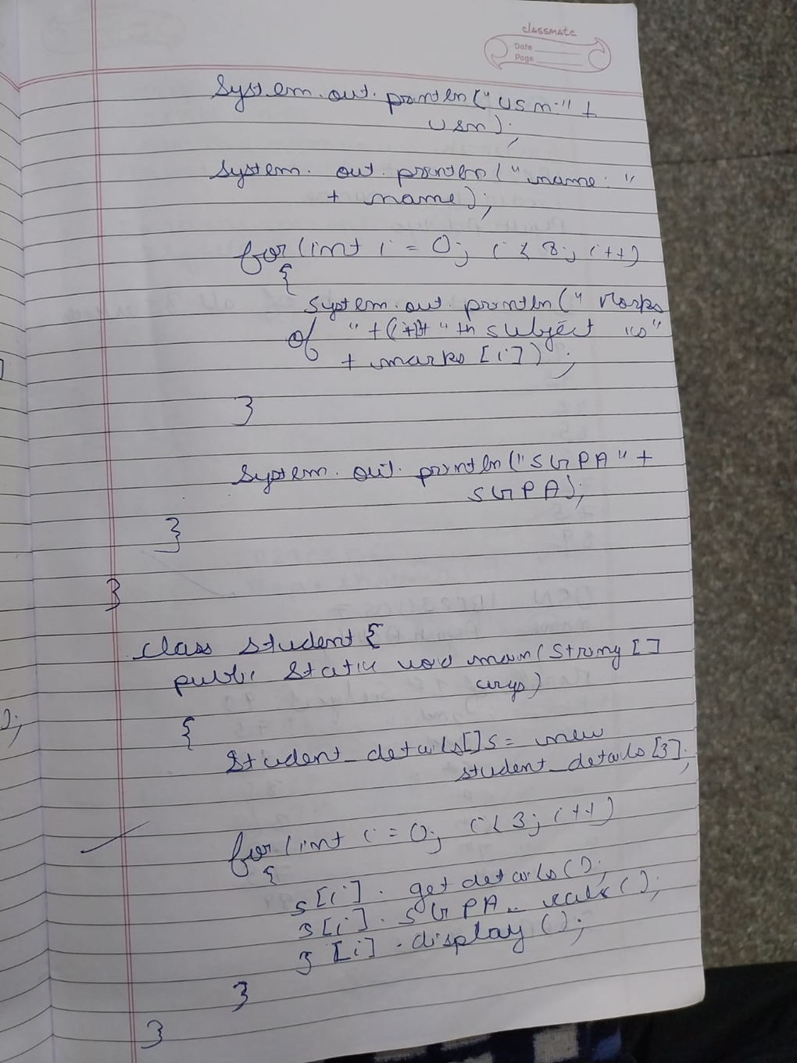

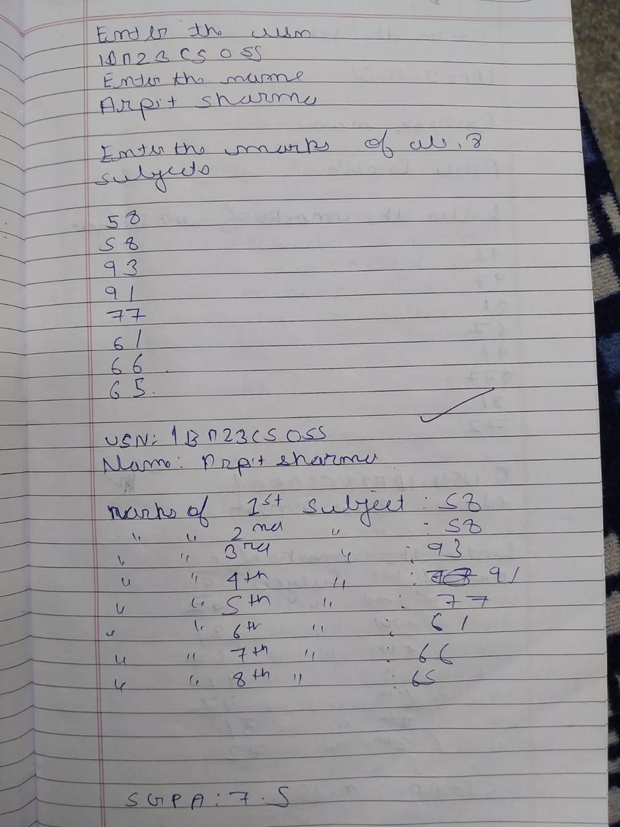

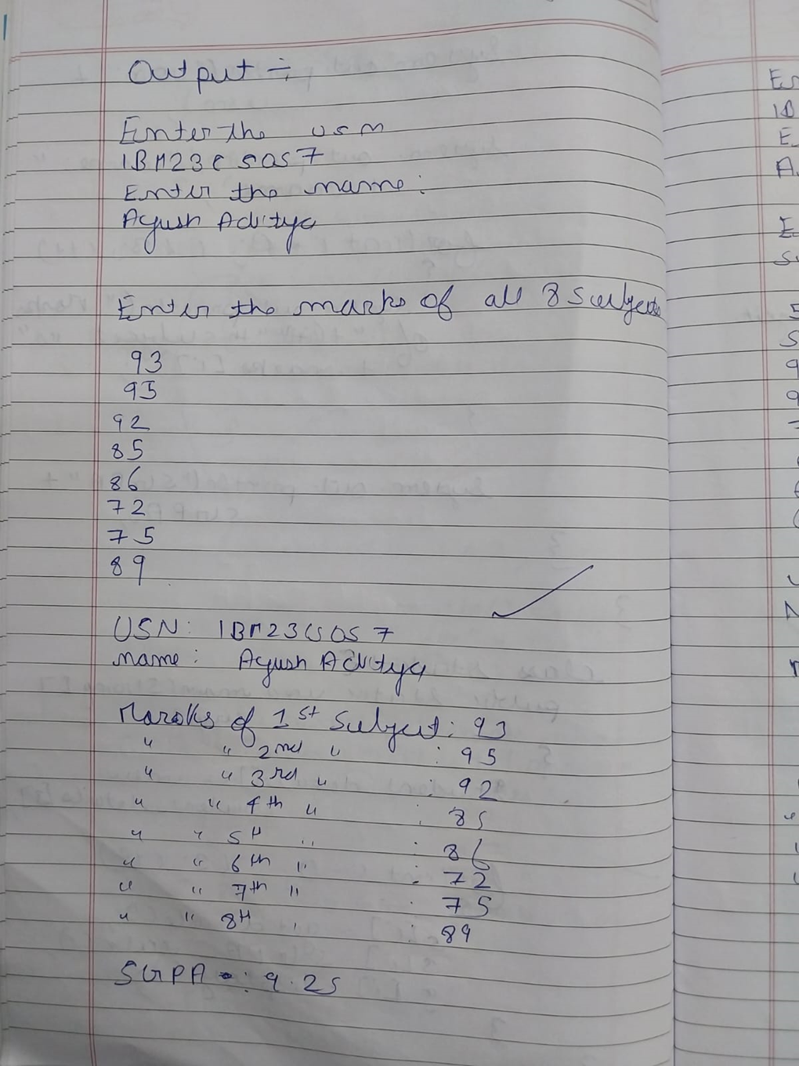3.Create a class Book which contains Book which contains four members:name,author,price,num_pages.Include a constructor to set the values for the members.Include a toString() method that could display the complete details of the book.Develop a java program to create n book objects.

Code-

import java.util.Scanner;

class Books {

String name;

String author;

int price;

int numPages;

Books(String name, String author, int price, int numPages) {

this.name = name;

this.author = author;

this.price = price;

this.numPages = numPages;

}

public String toString() {

String nameStr = "Book name: " + this.name + "\n";

String authorStr = "Author name: " + this.author + "\n";

String priceStr = "Price: " + this.price + "\n";

String numPagesStr = "Number of pages: " + this.numPages + "\n";

return nameStr + authorStr + priceStr + numPagesStr;

}

public static void main(String[] args) {

Scanner s = new Scanner(System.in);

int n = s.nextInt();

s.nextLine(); // Consume the newline after the integer input

Books[] b = new Books[n];

for (int i = 0; i < n; i++) {

String name = s.nextLine();

String author = s.nextLine();

int price = s.nextInt();

int numPages = s.nextInt();

s.nextLine(); // Consume the newline after the integer input

b[i] = new Books(name, author, price, numPages);

String result = b[i].toString();

System.out.println(result);

}

s.close(); // Close the scanner

}

}

Output-

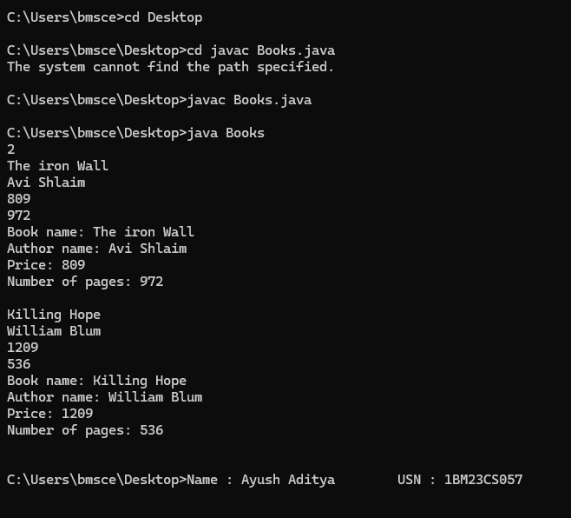

Obeservation-

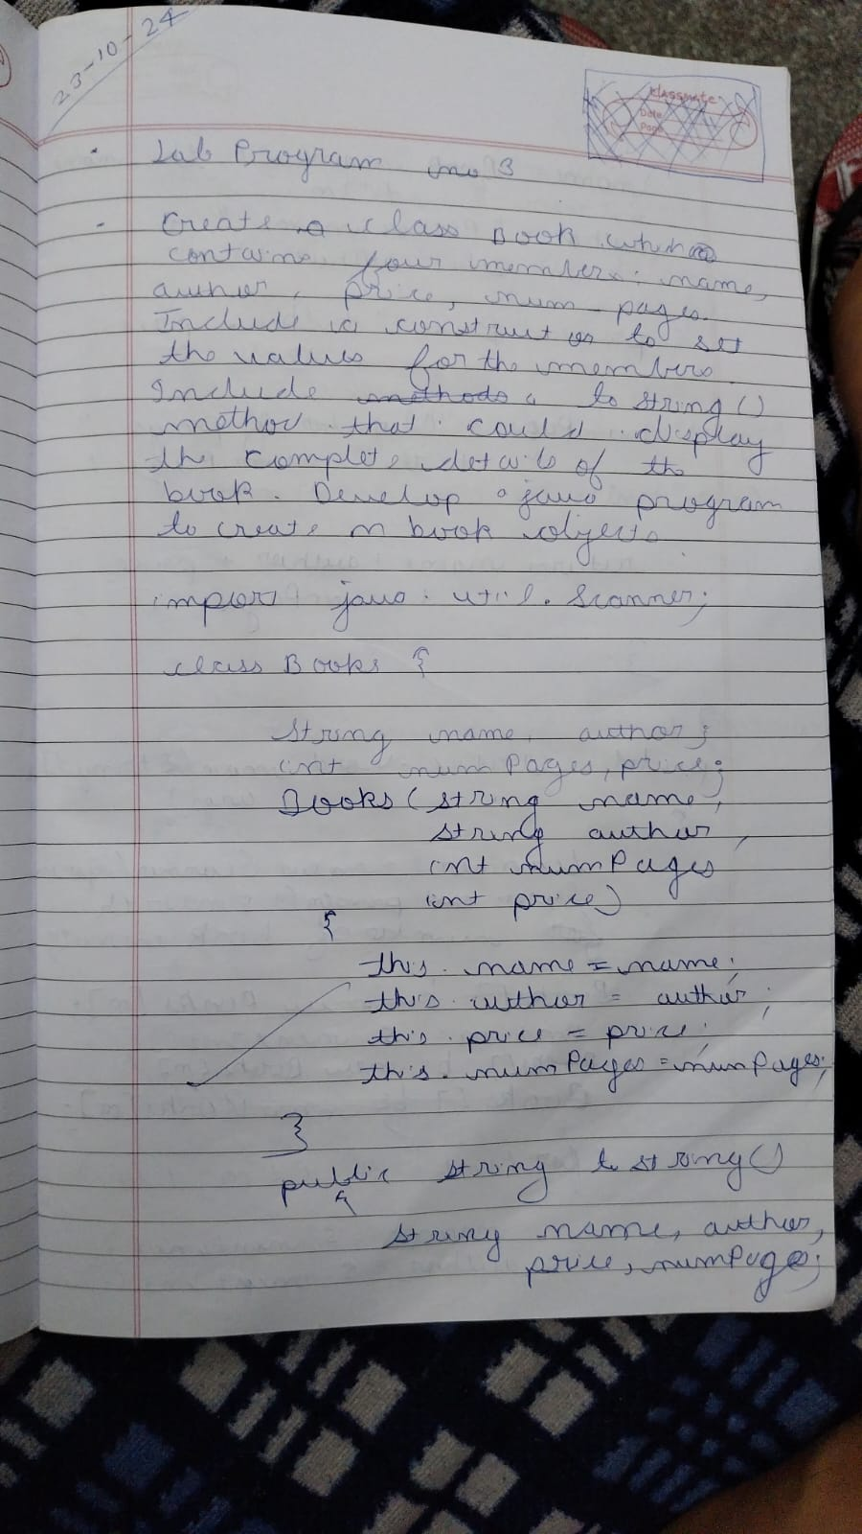

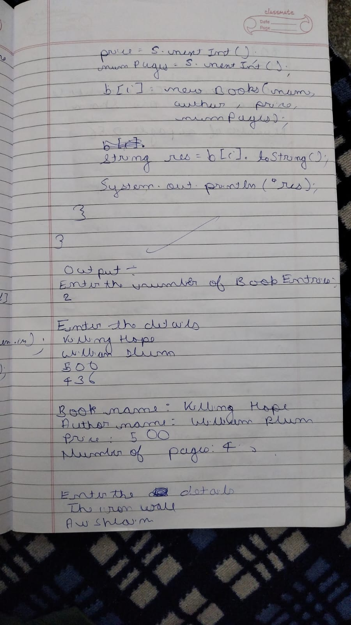

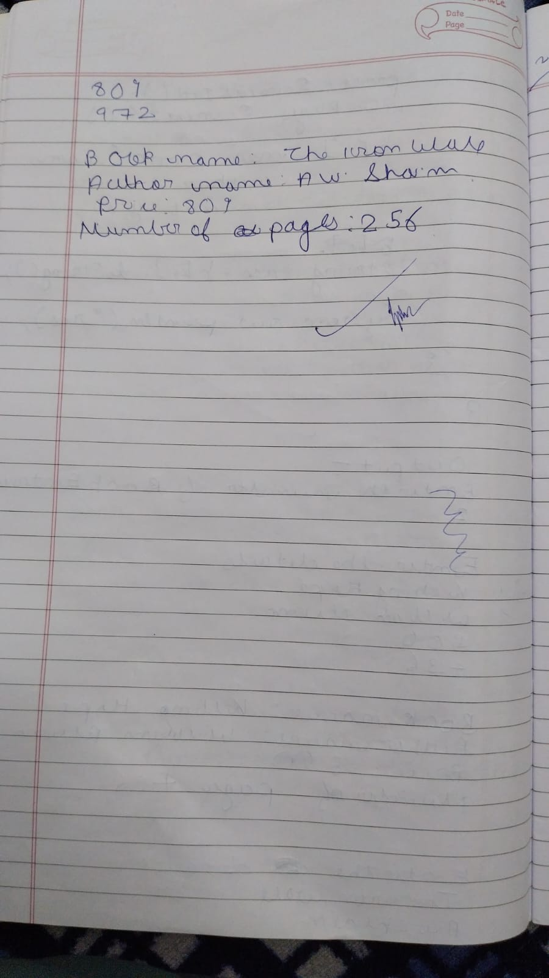

4.Develop a Java program to create an abstract class name shape that contains two integers and an empty method named printArea().Provide three classes named Rectangle,Triangle and Circle such that each one of the classes extends the class shape.Each one of the classes contain only the method printArea() that prints the area of the given Shape.

Code-

import java.util.Scanner;

abstract class Shape {

int dim1;

int dim2;

public Shape() {

this.dim1 = 0;

this.dim2 = 0;

}

public Shape(int dim1, int dim2) {

this.dim1 = dim1;

this.dim2 = dim2;

}

public abstract void printArea();

}

class Rectangle extends Shape {

public Rectangle(int length, int width) {

dim1 = length;

dim2 = width;

}

public void printArea() {

int area = dim1 * dim2;

System.out.println("Area of Rectangle: " + area);

}

}

class Triangle extends Shape {

public Triangle(int base, int height) {

dim1 = base;

dim2 = height;

}

public void printArea() {

double area = 0.5 * dim1 * dim2;

System.out.println("Area of Triangle: " + area);

}

}

class Circle extends Shape {

public Circle(int radius) {

dim1 = radius;

dim2 = 0;

}

public void printArea() {

double area = Math.PI * dim1 * dim1;

System.out.println("Area of Circle: " + area);

}

}

public class Shapes {

public static void main(String[] args) {

Scanner in = new Scanner(System.in);

System.out.println("This code is written by Ayush Aditya");

System.out.println("Enter length and width for Rectangle:");

int length = in.nextInt();

int width = in.nextInt();

Shape rectangle = new Rectangle(length, width);

rectangle.printArea();

System.out.println("Enter base and height for Triangle:");

int base = in.nextInt();

int height = in.nextInt();

Shape triangle = new Triangle(base, height);

triangle.printArea();

System.out.println("Enter radius for Circle:");

int radius = in.nextInt();

Shape circle = new Circle(radius);

circle.printArea();

in.close();

}

}

Output-

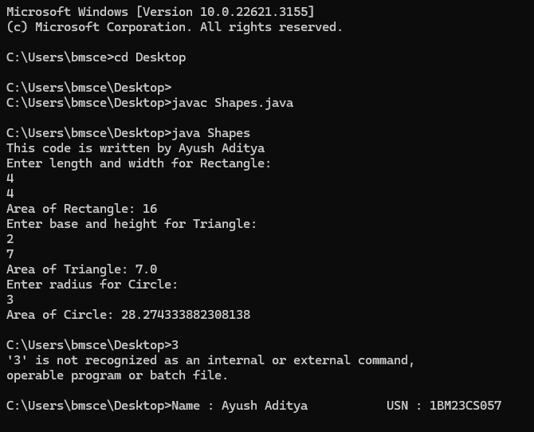

Observation-

-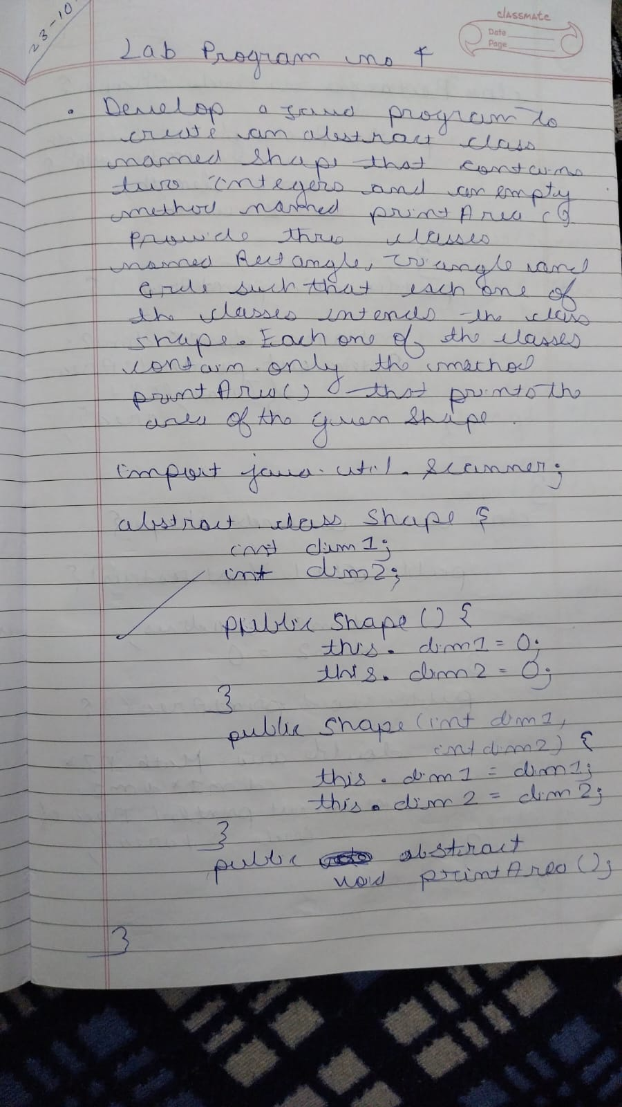

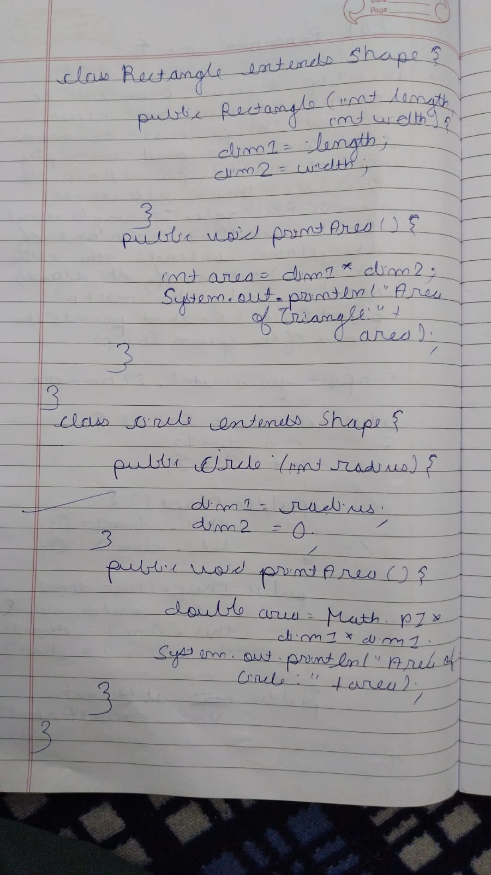

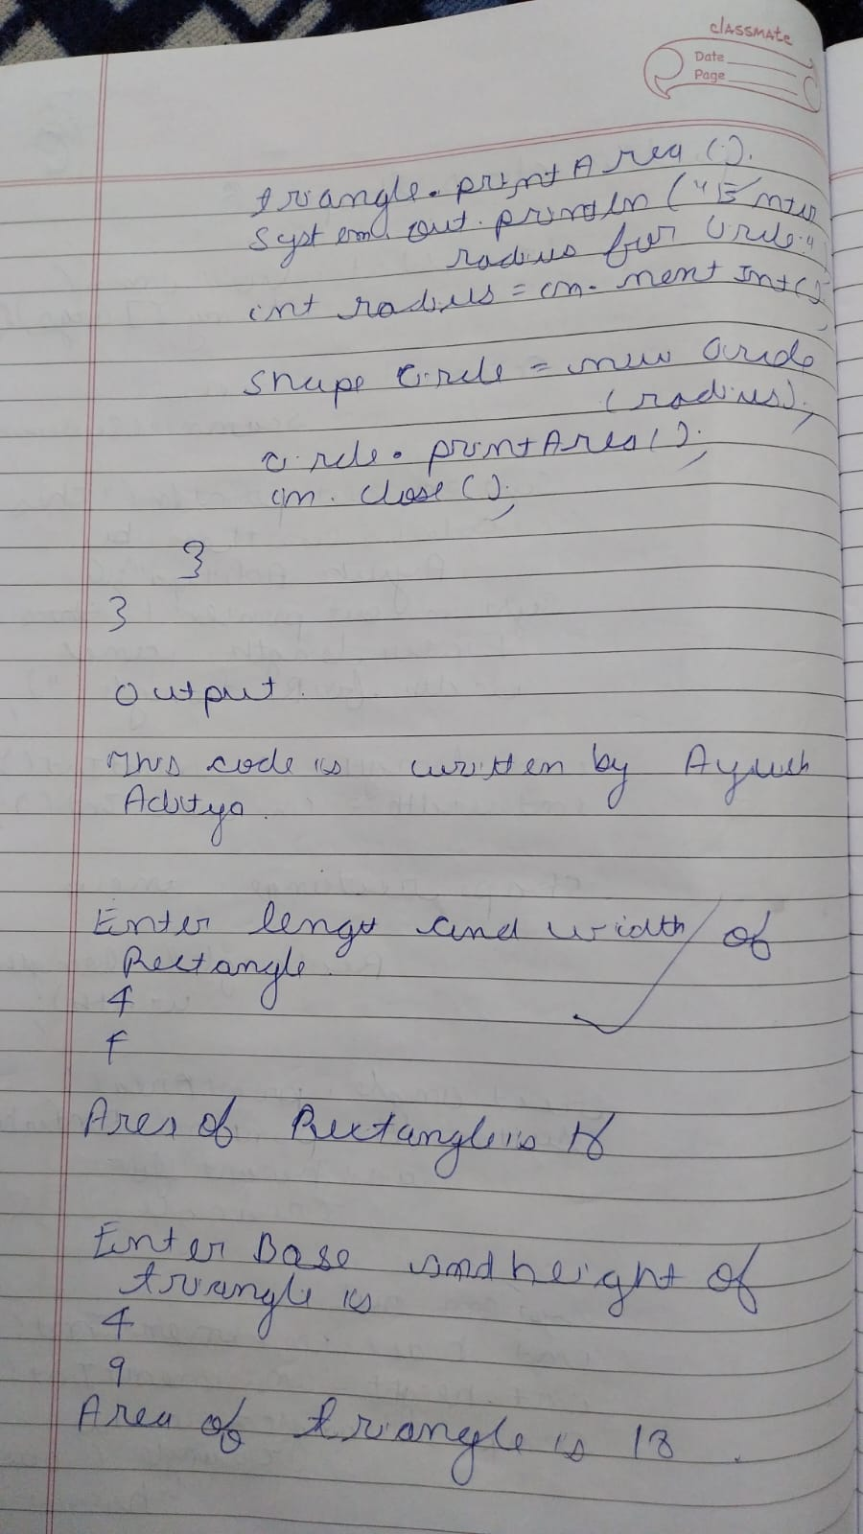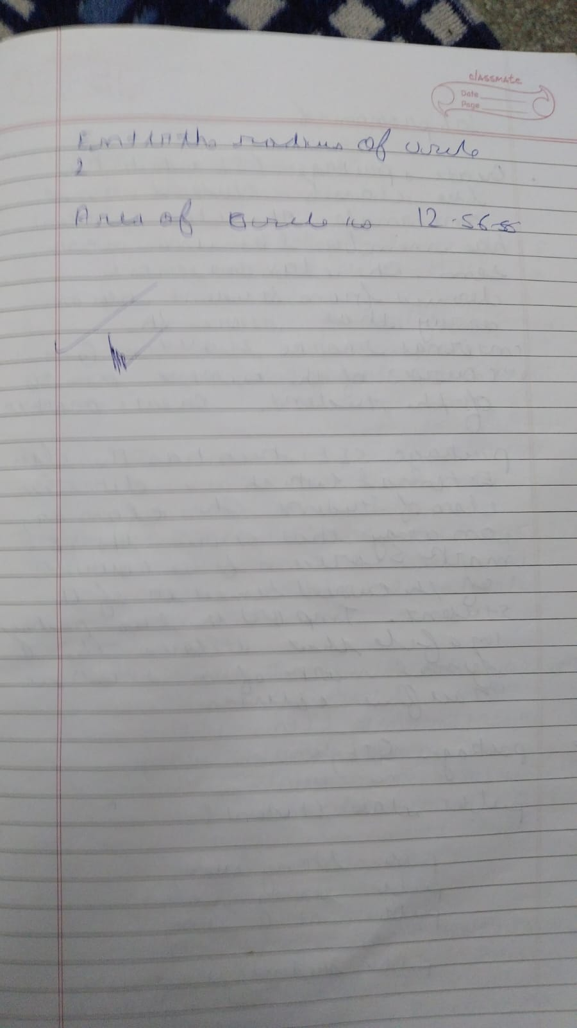

5. Develop a Java program to create a class Bank that maintains two kinds of account for its

customers, one called savings account and the other current account. The savings account provides

compound interest and withdrawal facilities but no cheque book facility. The current account

provides cheque book facility but no interest. Current account holders should also maintain a

minimum balance and if the balance falls below this level, a service charge is imposed.

Create a class Account that stores customer name, account number and type of account. From this

derive the classes Cur-acct and Sav-acct to make them more specific to their requirements. Include

the necessary methods in order to achieve the following tasks:

a)Accept deposit from customer and update the balance.

b)Display the balance.

c)Compute and deposit interest

d)Permit withdrawal and update the balance

e) Check for the minimum balance, impose penalty if necessary and update the balance.

Code- import java.util.Scanner;

class Account {

String customerName;

String accountNumber;

double balance;

String accountType;

public Account(String customerName, String accountNumber, String accountType) {

this.customerName = customerName;

this.accountNumber = accountNumber;

this.accountType = accountType;

this.balance = 0.0;

}

public void deposit(double amount) {

if (amount > 0) {

balance += amount;

System.out.println("Deposited: $" + amount);

} else {

System.out.println("Invalid deposit amount.");

}

}

public void displayBalance() {

System.out.println("Account Balance: $" + balance);

}

public void withdraw(double amount) {

if (amount > 0 && amount <= balance) {

balance -= amount;

System.out.println("Withdrew: $" + amount);

} else {

System.out.println("Insufficient balance or invalid withdrawal amount.");

}

}

}

class CurAcct extends Account {

static final double MIN_BALANCE = 500.0;

static final double SERVICE_CHARGE = 20.0;

public CurAcct(String customerName, String accountNumber) {

super(customerName, accountNumber, "Current");

}

public void checkAndImposeServiceCharge() {

if (balance < MIN_BALANCE) {

balance -= SERVICE_CHARGE;

System.out.println("Balance below minimum. Service charge of $" + SERVICE_CHARGE + " imposed.");

}

}

}

class SavAcct extends Account {

static final double INTEREST_RATE = 0.05;

// Constructor

public SavAcct(String customerName, String accountNumber) {

super(customerName, accountNumber, "Savings");

}

// Method to compute and deposit interest

public void computeAndDepositInterest() {

double interest = balance * INTEREST_RATE;

balance += interest;

System.out.println("Interest of $" + interest + " has been added to your savings.");

}

}

public class Bank {

public static void main(String[] args) {

Scanner scanner = new Scanner(System.in);

Account acc1 = new CurAcct("John Doe", "12345");

Account acc2 = new SavAcct("Jane Smith", "67890");

while (true) {

System.out.println("\n--- Bank Menu ---");

System.out.println("1. Deposit");

System.out.println("2. Withdraw");

System.out.println("3. Display Balance");

System.out.println("4. Compute Interest (Savings Account)");

System.out.println("5. Check Service Charge (Current Account)");

System.out.println("6. Exit");

System.out.print("Enter choice: ");

int choice = scanner.nextInt();

switch (choice) {

case 1:

System.out.print("Enter account type (Current/Savings): ");

String accountType = scanner.next();

System.out.print("Enter deposit amount: ");

double depositAmount = scanner.nextDouble();

if (accountType.equalsIgnoreCase("Current")) {

acc1.deposit(depositAmount);

} else if (accountType.equalsIgnoreCase("Savings")) {

acc2.deposit(depositAmount);

} else {

System.out.println("Invalid account type.");

}

break;

case 2:

System.out.print("Enter account type (Current/Savings): ");

accountType = scanner.next();

System.out.print("Enter withdrawal amount: ");

double withdrawalAmount = scanner.nextDouble();

if (accountType.equalsIgnoreCase("Current")) {

acc1.withdraw(withdrawalAmount);

} else if (accountType.equalsIgnoreCase("Savings")) {

acc2.withdraw(withdrawalAmount);

} else {

System.out.println("Invalid account type.");

}

break;

case 3:

System.out.print("Enter account type (Current/Savings): ");

accountType = scanner.next();

if (accountType.equalsIgnoreCase("Current")) {

acc1.displayBalance();

} else if (accountType.equalsIgnoreCase("Savings")) {

acc2.displayBalance();

} else {

System.out.println("Invalid account type.");

}

break;

case 4:

if (acc2 instanceof SavAcct) {

((SavAcct) acc2).computeAndDepositInterest();

} else {

System.out.println("Interest can only be computed for Savings accounts.");

}

break;

case 5:

if (acc1 instanceof CurAcct) {

((CurAcct) acc1).checkAndImposeServiceCharge();

} else {

System.out.println("Service charge can only be applied to Current accounts.");

}

break;

case 6:

System.out.println("Exiting the program.");

scanner.close();

return;

default:

System.out.println("Invalid choice. Please try again.");

}

}

}

}

Output-

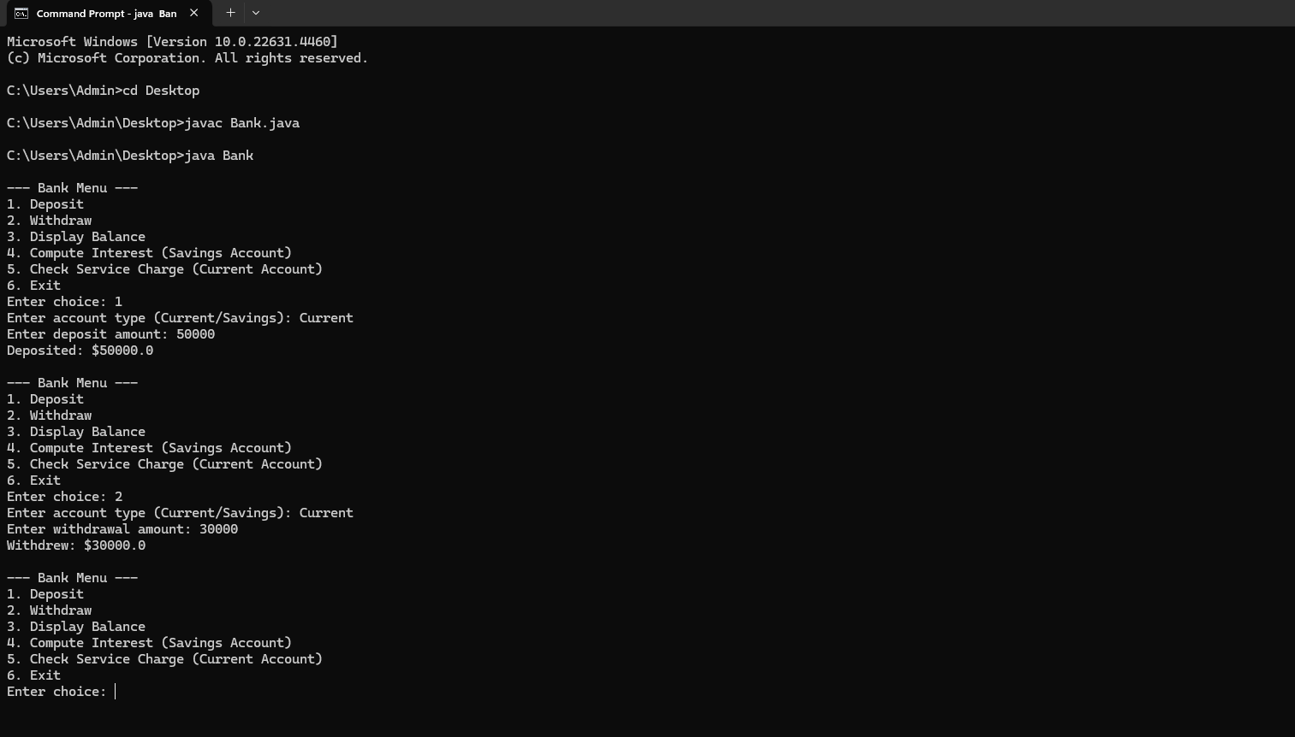

Observation-

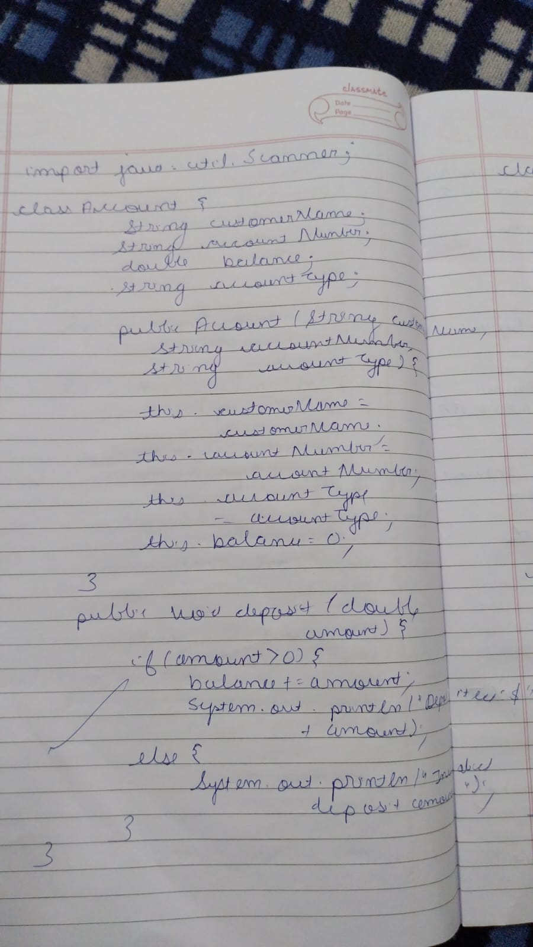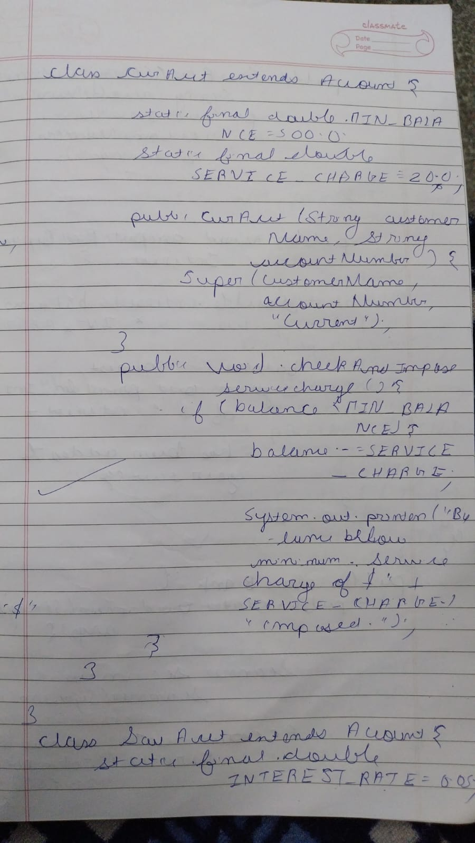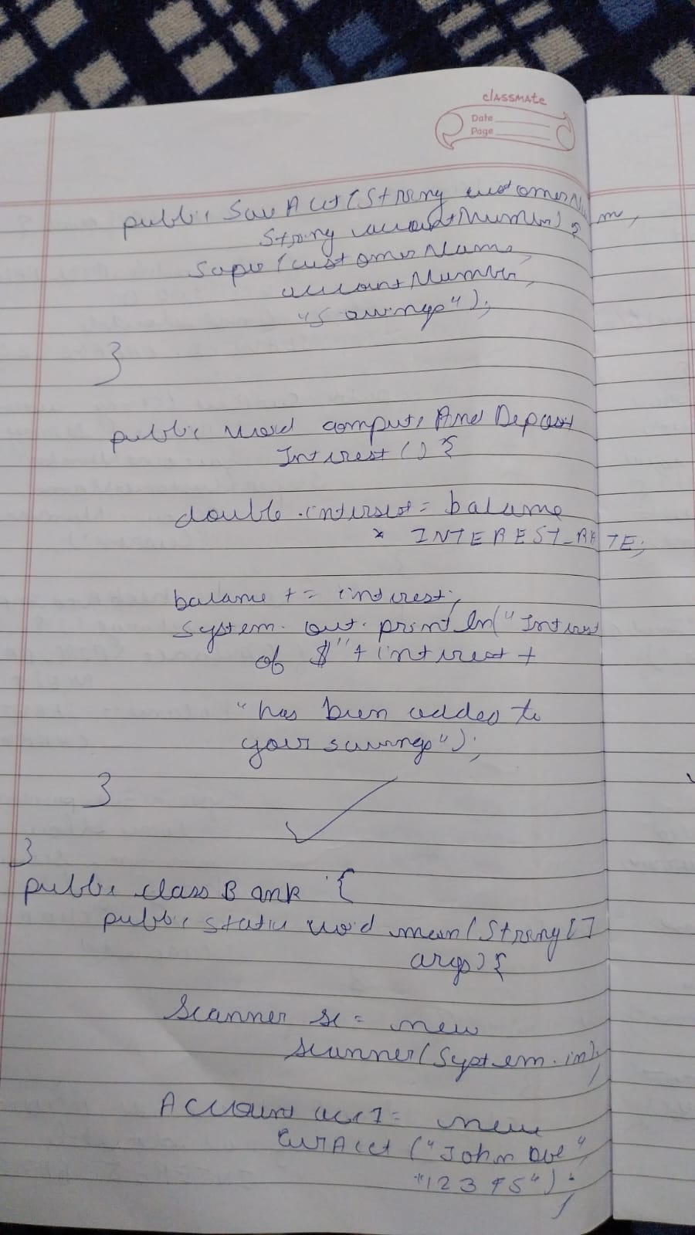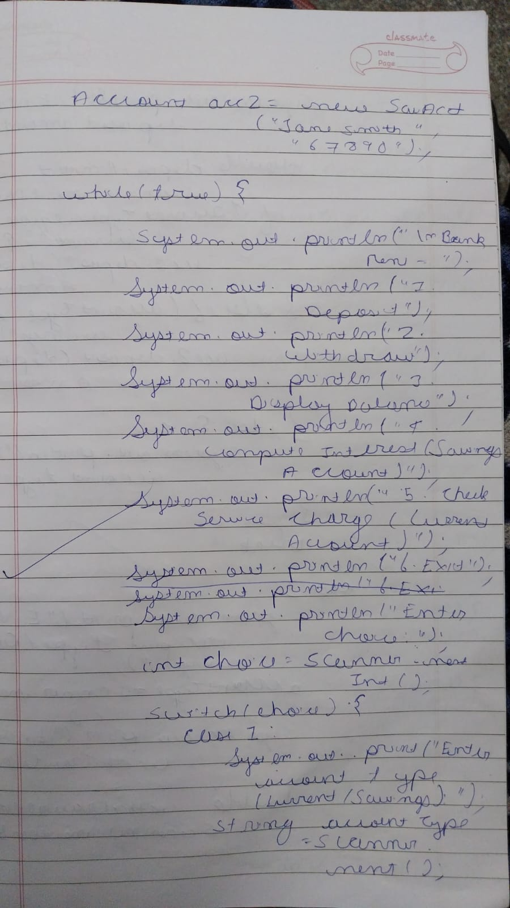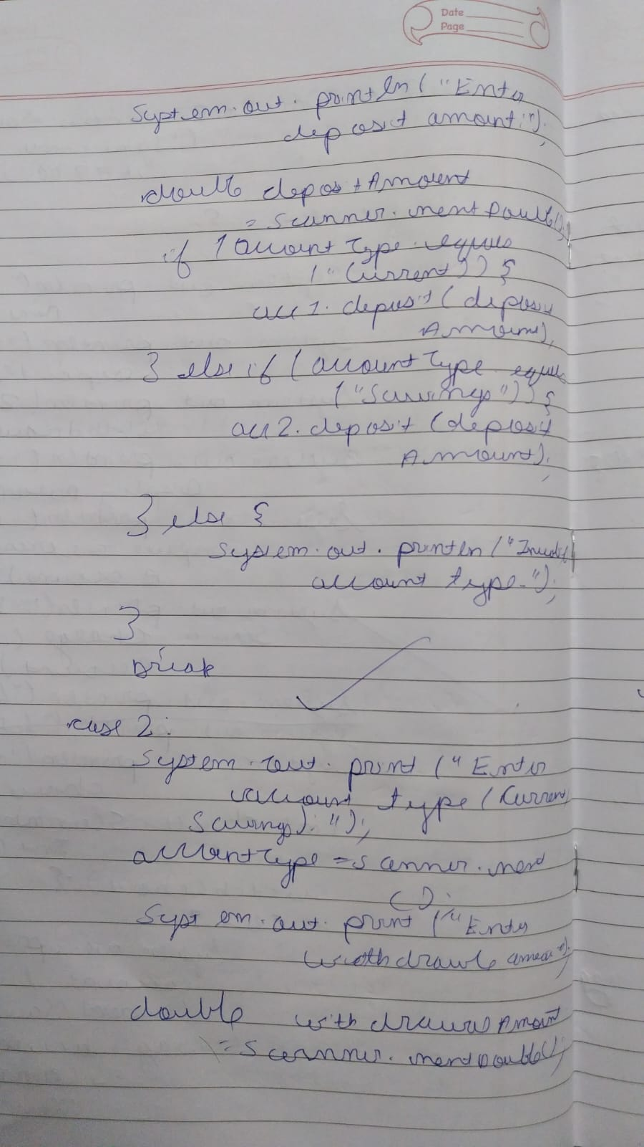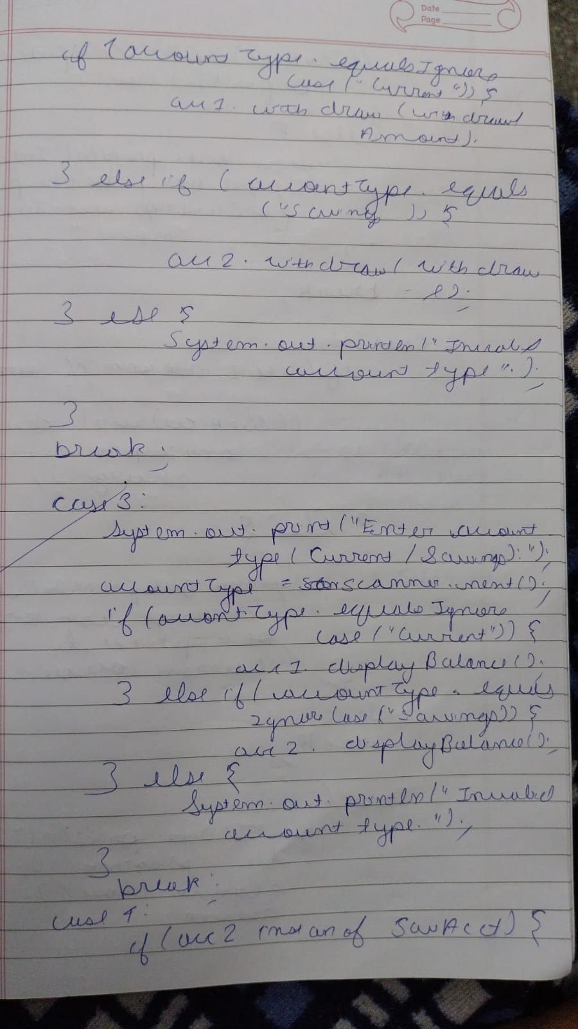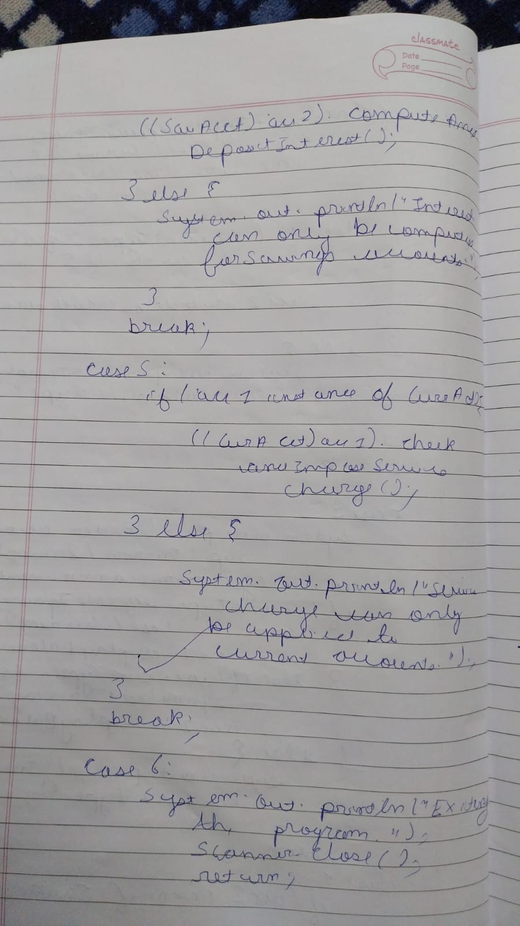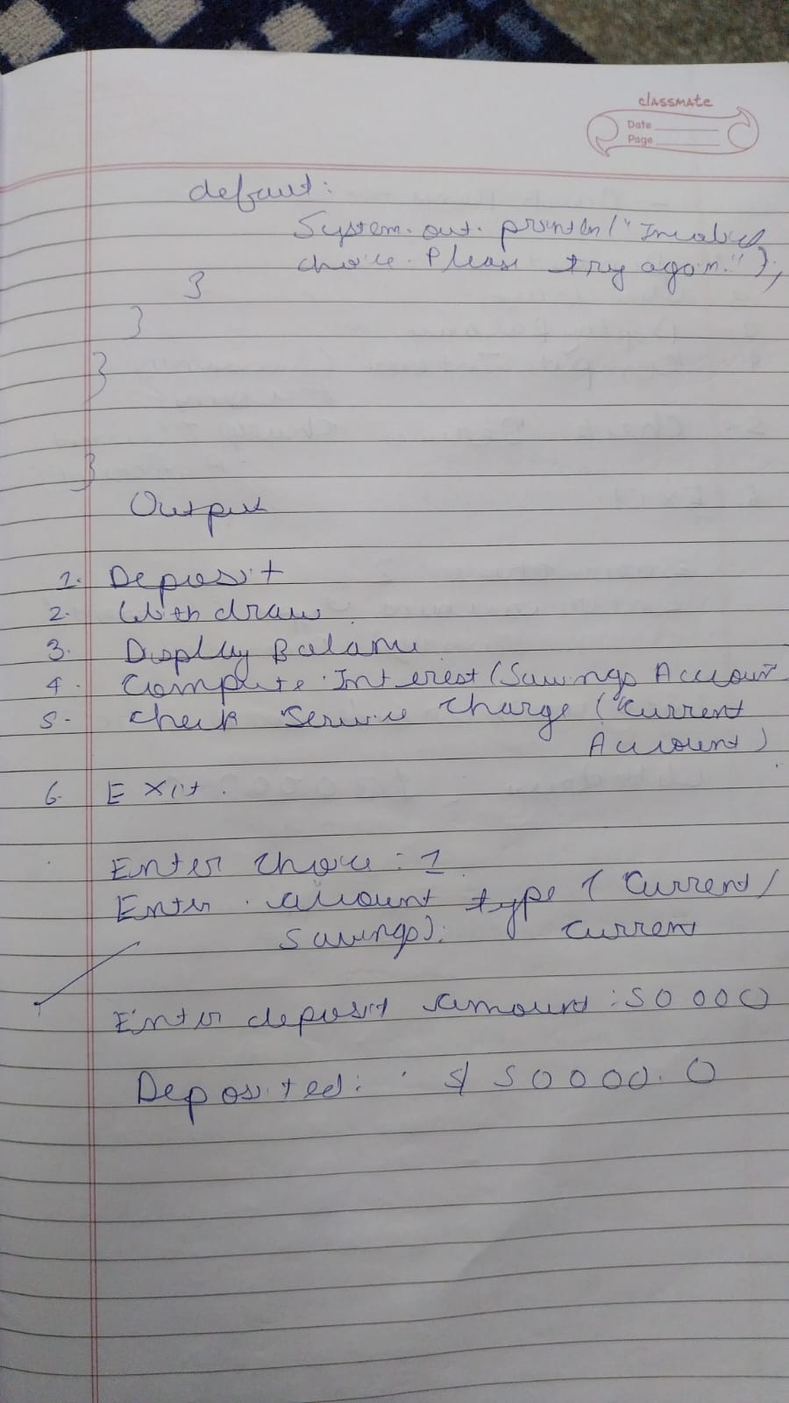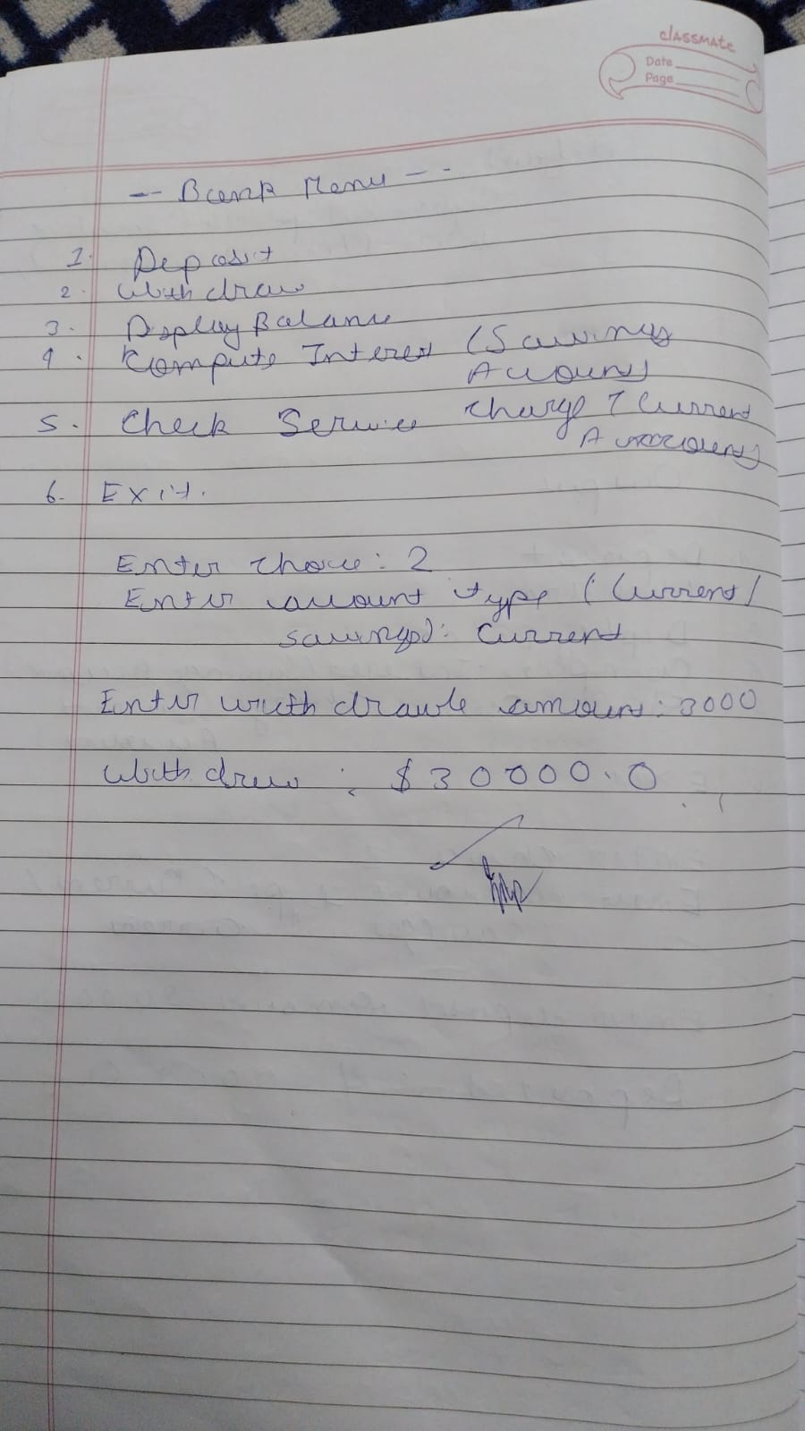

6. Create a package CIE which has two classes- Student and Internals. The class

Student has members like usn, name, sem. The class Internals derived from

Student has an array that stores the internal marks scored in five courses of the

current semester of the student. Create another package SEE which has the class

External which is a derived class of Student. This class has an array that stores the

SEE marks scored in five courses of the current semester of the student. Import

the two packages in a file that declares the final marks of n students in all five

courses.

Code-

package CIE;

public class Student {

protected String usn;

protected String name;

protected int sem;

// Constructor to initialize student details

public Student(String usn, String name, int sem) {

this.usn = usn;

this.name = name;

this.sem = sem;

}

// Display student details

public void displayStudentInfo() {

System.out.println("USN: " + usn);

System.out.println("Name: " + name);

System.out.println("Semester: " + sem);

}

}

public class Internals extends Student {

protected int[] internalMarks;

public Internals(String usn, String name, int sem, int[] internalMarks) {

super(usn, name, sem);

this.internalMarks = internalMarks;

}

public void displayInternalMarks() {

System.out.println("Internal Marks for the student:");

for (int i = 0; i < internalMarks.length; i++) {

System.out.println("Course " + (i+1) + ": " + internalMarks[i]);

}

}

}

package SEE;

import CIE.Student;

public class External extends Student {

protected int[] externalMarks;

public External(String usn, String name, int sem, int[] externalMarks) {

super(usn, name, sem);

this.externalMarks = externalMarks;

}

public void displayExternalMarks() {

System.out.println("External Marks for the student:");

for (int i = 0; i < externalMarks.length; i++) {

System.out.println("Course " + (i+1) + ": " + externalMarks[i]);

}

}

}

import CIE.Internals;

import SEE.External;

import java.util.Scanner;

public class StudentMarks {

public static void main(String[] args) {

Scanner scanner = new Scanner(System.in);

System.out.print("Enter number of students: ");

int n = scanner.nextInt();

scanner.nextLine();

Internals[] internalsArray = new Internals[n];

External[] externalsArray = new External[n];

for (int i = 0; i < n; i++) {

System.out.println("\nEnter details for Student " + (i+1));

System.out.print("USN: ");

String usn = scanner.nextLine();

System.out.print("Name: ");

String name = scanner.nextLine();

System.out.print("Semester: ");

int sem = scanner.nextInt();

scanner.nextLine();

int[] internalMarks = new int[5];

System.out.println("Enter internal marks for 5 courses:");

for (int j = 0; j < 5; j++) {

internalMarks[j] = scanner.nextInt();

}

scanner.nextLine();

internalsArray[i] = new Internals(usn, name, sem, internalMarks);

int[] externalMarks = new int[5];

System.out.println("Enter external marks (SEE) for 5 courses:");

for (int j = 0; j < 5; j++) {

externalMarks[j] = scanner.nextInt();

}

scanner.nextLine();

externalsArray[i] = new External(usn, name, sem, externalMarks);

}

System.out.println("\n--- Final Marks of Students ---");

for (int i = 0; i < n; i++) {

System.out.println("\nDetails of Student " + (i+1));

internalsArray[i].displayStudentInfo();

internalsArray[i].displayInternalMarks();

externalsArray[i].displayExternalMarks();

int totalInternalMarks = 0;

for (int mark : internalsArray[i].internalMarks) {

totalInternalMarks += mark;

}

int totalExternalMarks = 0;

for (int mark : externalsArray[i].externalMarks) {

totalExternalMarks += mark;

}

int finalMarks = totalInternalMarks + totalExternalMarks;

System.out.println("Final Marks: " + finalMarks);

}

scanner.close();

}

}

7.Write a program that demonstrate handling of exception in inheritance String.Create a base class called Father and a derived class called son which extends the base class in Father’s class implement a constructor that takes the age and throws exception Wrong age when input age is less than 0.In son’s class implements constructor uses both father’s and son’s age and throws an exception when son’s age >= father’s age.

Code-

class WrongAgeException extends Exception {

public WrongAgeException(String message) {

super(message);

}

}

class Father {

protected int age;

public Father(int age) throws WrongAgeException {

if (age < 0) {

throw new WrongAgeException("Age cannot be less than 0.");

}

this.age = age;

System.out.println("Father's age: " + this.age);

}

}

class Son extends Father {

private int sonAge;

public Son(int fatherAge, int sonAge) throws WrongAgeException {

super(fatherAge);

if (sonAge < 0) {

throw new WrongAgeException("Son's age cannot be less than 0.");

}

if (sonAge >= fatherAge) {

throw new WrongAgeException("Son's age cannot be greater than or equal to father's age.");

}

this.sonAge = sonAge;

System.out.println("Son's age: " + this.sonAge);

}

}

public class Main {

public static void main(String[] args) {

try {

Father father = new Father(-5);

} catch (WrongAgeException e) {

System.out.println("Error: " + e.getMessage());

}

try {

Son son = new Son(40, 45);

} catch (WrongAgeException e) {

System.out.println("Error: " + e.getMessage());

}

try {

Son son = new Son(40, -10);

} catch (WrongAgeException e) {

System.out.println("Error: " + e.getMessage());

}

try {

Son son = new Son(40, 20);

} catch (WrongAgeException e) {

System.out.println("Error: " + e.getMessage());

}

}

}

Output-

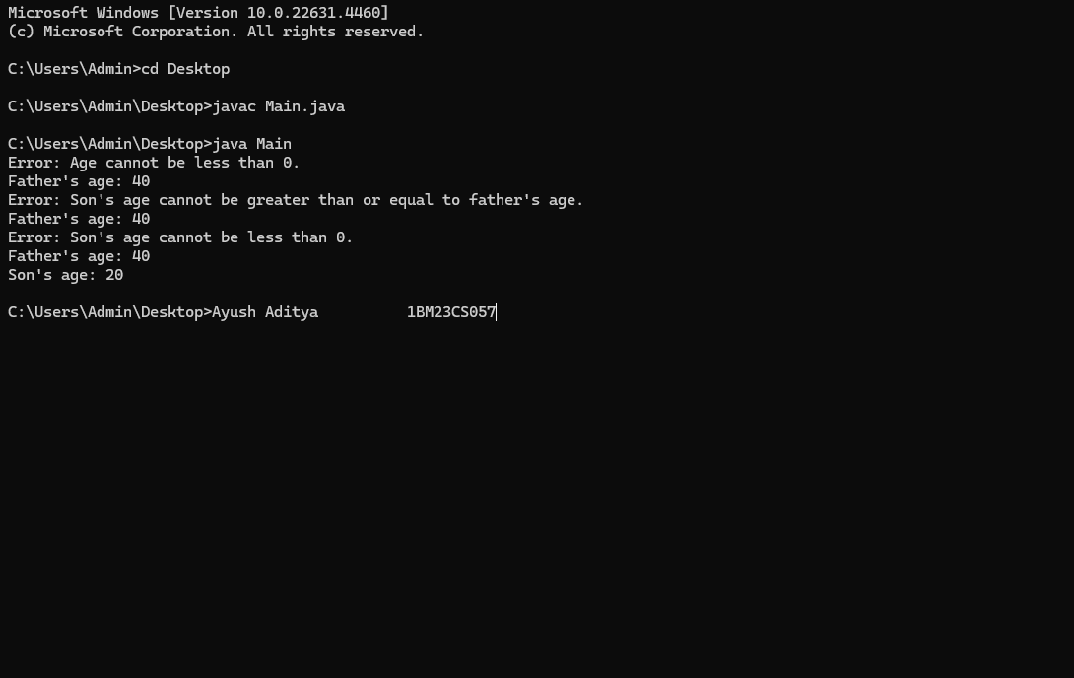

Observation-

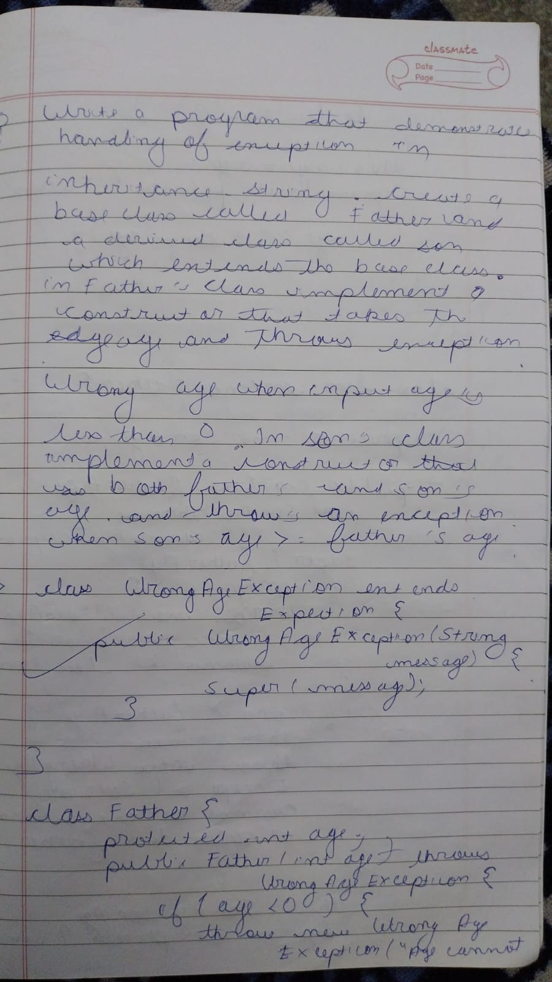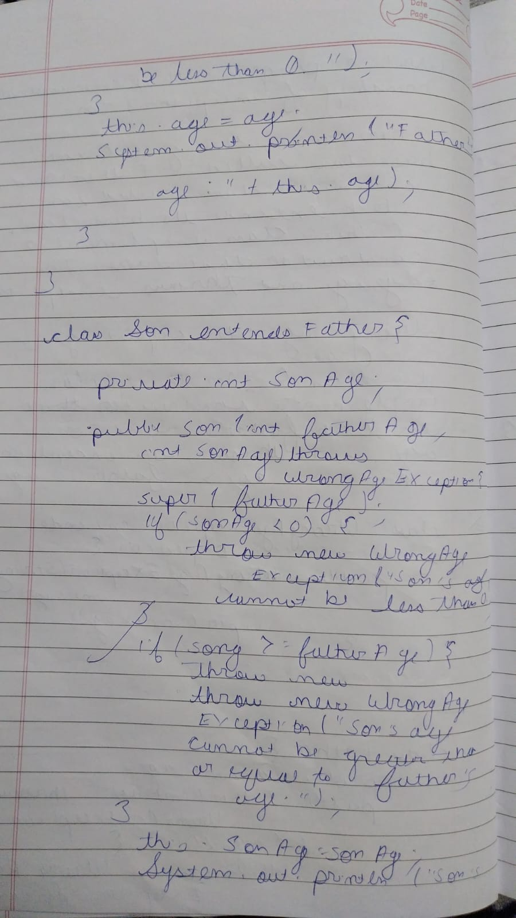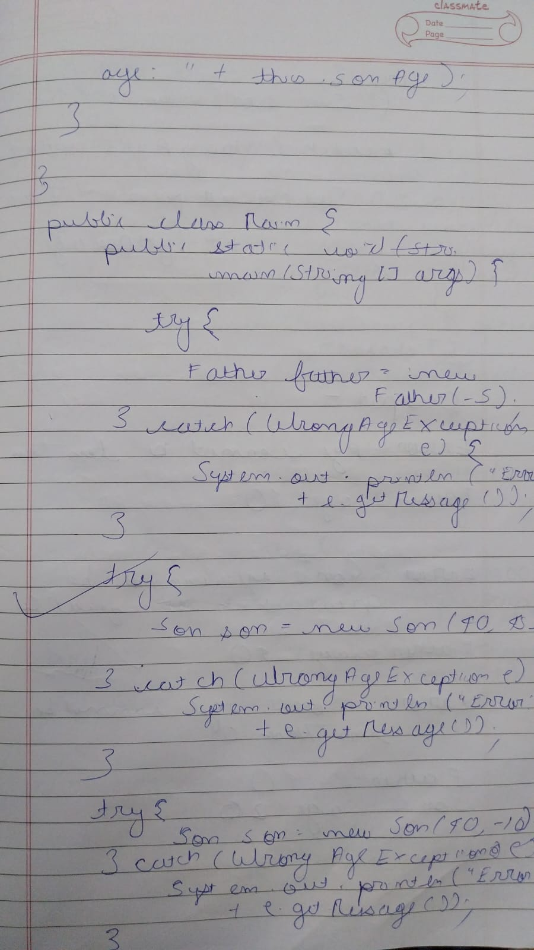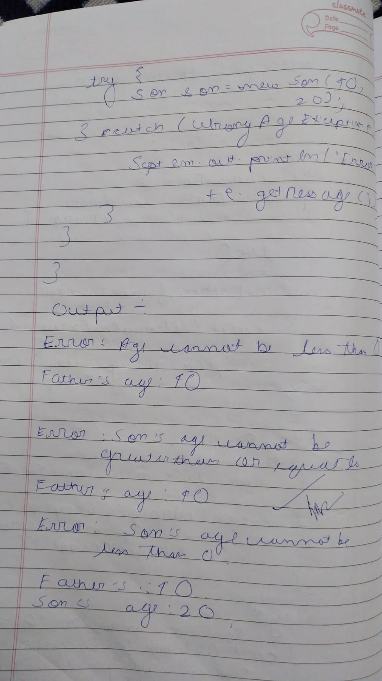

8. Write a program which creates two threads, one thread displaying “BMS College of Engineering” once every ten seconds and another displaying “CSE” once every two seconds.

Code-

public class MultiThreadExample {

static class DisplayBMS implements Runnable {

@Override

public void run() {

while (true) {

System.out.println("BMS College of Engineering");

try {

Thread.sleep(10000); // Sleep for 10 seconds

} catch (InterruptedException e) {

Thread.currentThread().interrupt(); // Handle thread interruption

}

}

}

}

static class DisplayCSE implements Runnable {

@Override

public void run() {

while (true) {

System.out.println("CSE");

try {

Thread.sleep(2000); // Sleep for 2 seconds

} catch (InterruptedException e) {

Thread.currentThread().interrupt(); // Handle thread interruption

}

}

}

}

public static void main(String[] args) {

// Create two thread objects for each task

Thread thread1 = new Thread(new DisplayBMS());

Thread thread2 = new Thread(new DisplayCSE());

thread1.start();

thread2.start();

}

Output-

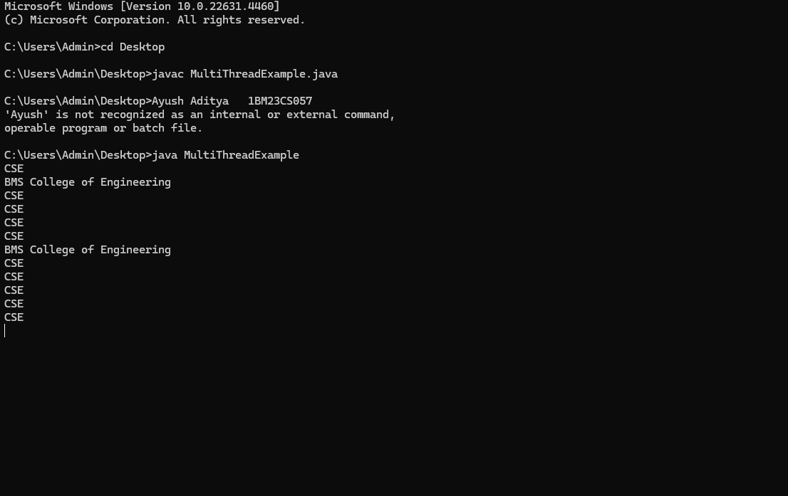

9.Write a program that creates a user interface to perform integer divisions. The user enters two numbers in the text fields, Num1 and Num2. The division of Num1 and Num2 is displayed in the Result field when the Divide button is clicked. If Num1 or Num2 were not an integer, the program would throw a NumberFormatException. If Num2 were Zero, the program would throw an Arithmetic Exception Display the exception in a message dialog box.

Observation copy-

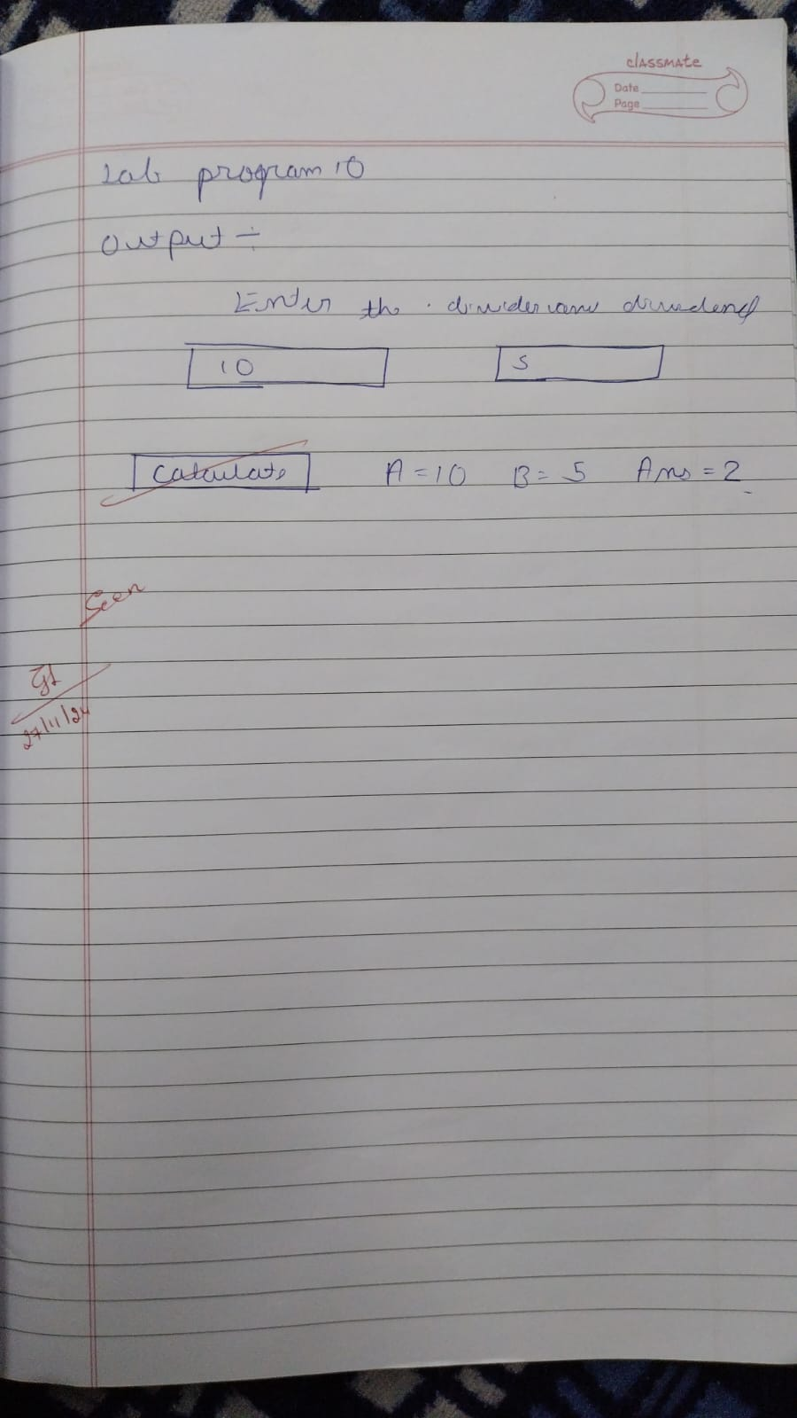

10. Write a Java program to create two threads, one displays “Computer Science” and another display “Information Science” five times.

Observation-

